Exercise: Android Layout
Document Number: |  | Issue Number:  Date:

TABLE OF CONTENTS
1 Exercise 1: Create a message form with Linear Layout 2
1.1 Description 2
1.2 Create new Project. 2
1.3 Create new activity for Linear Layout 2
1.4 Design layout for message form, use Linear layout as parent. 2
1.5 Update control’s event in Activity class. 4
2 Exercise 2: Create a simple login form with Relative Layout 4
2.1 Description 4
2.2 Create new Activity 4
2.3 Design a simple login form, use Relative Layout as parent 5
2.4 Update control’s event in Activity class 6
3 Create a simple menu use Table Layout 7
3.1 Description 7
3.2 Create new Activity 7
3.3 Design a simple login form, use Table Layout as parent 8
3.4 Create a product object 10
3.5 Update control’s event in Activity class 10

Exercise 1: Create a message form with Linear Layout

Description
The purpose of this exercise is make students get familiar with Linear Layout in Android software development. At the end of this exercise, student knows and can use Linear Layout to build application.

Create new Project.
In Eclipse, create new project with default activity.

Create new activity for Linear Layout
In new Project, create new Activity for Linear layout. Change AndroidManifest.xml to launch this new activity as default.

Design layout for message form, use Linear layout as parent.
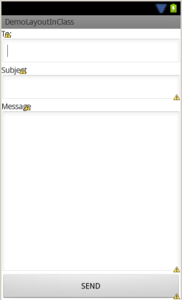

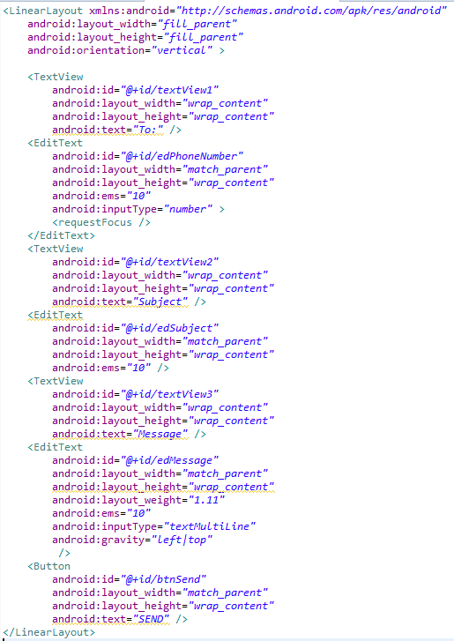

Update control’s event in Activity class.
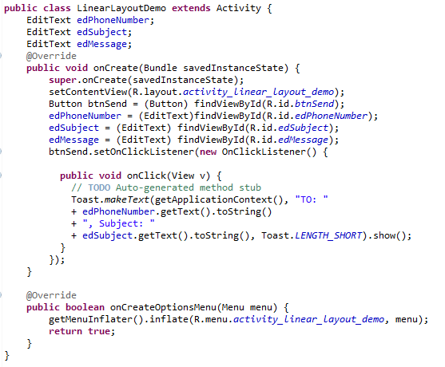

Exercise 2: Create a simple login form with Relative Layout

Description
The purpose of this exercise is make students get familiar with Relative Layout in Android software development. At the end of this exercise, student knows and can use Relative Layout to build application.

Create new Activity
Use current project, create new activity for relative layout. Change AndroidManifest.xml to launch this new activity as default.

Design a simple login form, use Relative Layout as parent
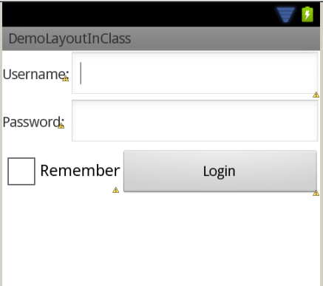

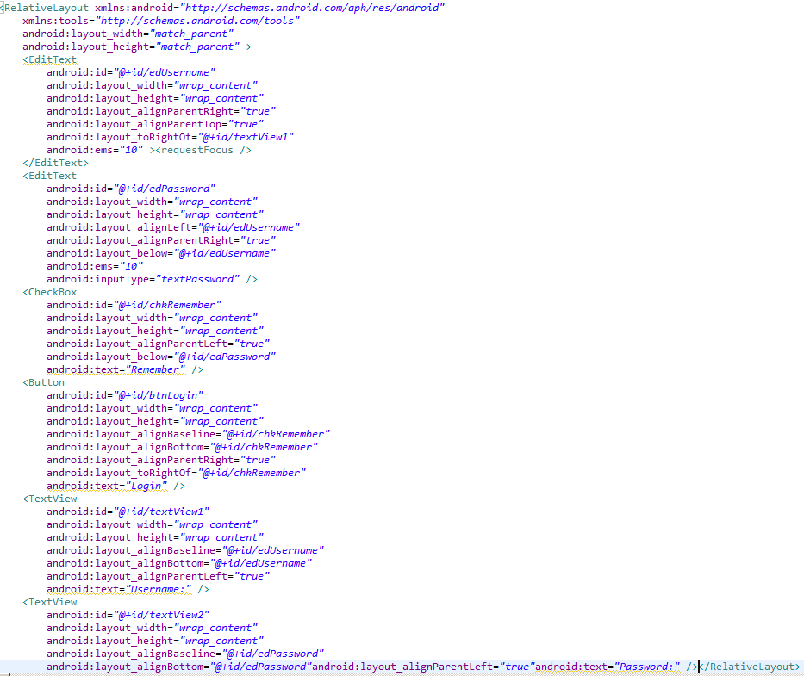

Update control’s event in Activity class

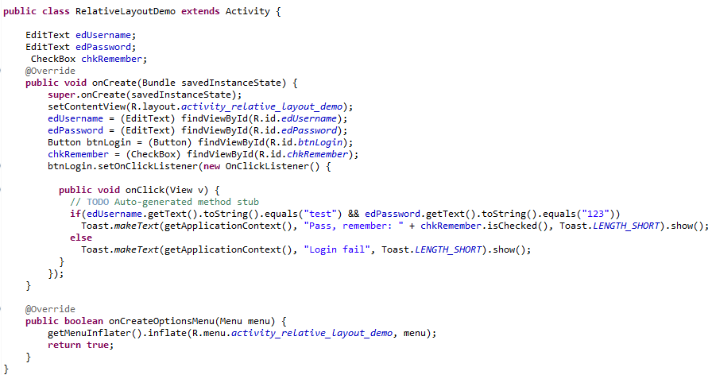

Create a simple menu use Table Layout

Description
The purpose of this exercise is make students get familiar with Table Layout in Android software development. At the end of this exercise, student knows and can use Table Layout to build application.

Create new Activity
Use current project, create new activity for table layout. Change AndroidManifest.xml to launch this new activity as default.

Design a simple login form, use Table Layout as parent
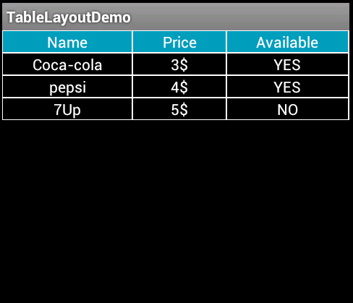

<TableLayout xmlns:android="http://schemas.android.com/apk/res/android"
android:layout_width="fill_parent"
android:layout_height="fill_parent"
android:stretchColumns="*"
android:shrinkColumns="*"
android:background="#000000"
android:id="@+id/tableLayout1" >
<TableRow
android:id="@+id/tableRow1"
android:layout_width="wrap_content"
android:layout_height="wrap_content"
android:background="#ffffff">
<TextView
android:id="@+id/textView1"
android:layout_width="wrap_content"
android:layout_height="wrap_content"
android:text="Name"
android:background="#079CBA"
android:layout_margin="1px"
android:textColor="#ffffff"
android:gravity="center"/>
<TextView
android:id="@+id/textView2"
android:layout_width="wrap_content"
android:layout_height="wrap_content"
android:text="Price"
android:background="#079CBA"
android:layout_margin="1px"
android:textColor="#ffffff"
android:gravity="center"/>
<TextView
android:id="@+id/textView3"
android:layout_width="wrap_content"
android:layout_height="wrap_content"
android:text="Available"
android:background="#079CBA"
android:layout_margin="1px"
android:textColor="#ffffff"
android:gravity="center"/></TableRow>
<TableRow
android:id="@+id/tableRow2"
android:layout_width="wrap_content"
android:layout_height="wrap_content"
android:background="#ffffff">
<TextView
android:id="@+id/textView4"
android:layout_width="wrap_content"
android:layout_height="wrap_content"
android:text="Coca-cola"
android:background="#000000"
android:layout_margin="1px"
android:textColor="#ffffff"
android:gravity="center"/>
<TextView
android:id="@+id/textView5"
android:layout_width="wrap_content"
android:layout_height="wrap_content"
android:text="3$"
android:background="#000000"
android:layout_margin="1px"
android:textColor="#ffffff"
android:gravity="center"/>
<TextView
android:id="@+id/textView6"
android:layout_width="wrap_content"
android:layout_height="wrap_content"
android:text="YES"
android:background="#000000"
android:layout_margin="1px"
android:textColor="#ffffff"
android:gravity="center"/>
</TableRow>
</TableLayout>

Create a product object
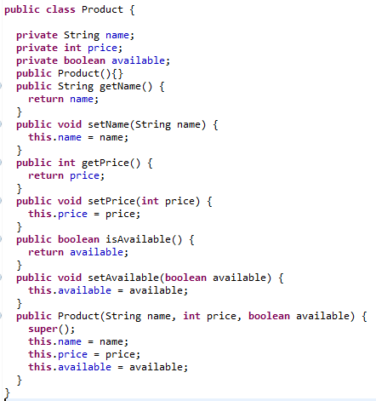

Update control’s event in Activity class
public class TableLayoutDemo extends Activity {

TableLayout table;
List<Product> listProduct;
@Override
public void onCreate(Bundle savedInstanceState) {
super.onCreate(savedInstanceState);
setContentView(R.layout.activity_table_layout_demo);
table = (TableLayout) findViewById(R.id.tableLayout1);
listProduct = new ArrayList<Product>();
Product p1 = new Product("pepsi", 4, true);
Product p2 = new Product("7Up", 5, false);
listProduct.add(p1);
listProduct.add(p2);
}
@Override
protected void onStart() {
super.onStart();

}
@Override
protected void onResume() {
super.onResume();
for (Product p : listProduct) {
TableRow row = new TableRow(this);
row.setBackgroundColor(getResources().getColor(R.color.white));
TextView productName = new TextView(this);
LayoutParams params = new LayoutParams(LayoutParams.WRAP_CONTENT, LayoutParams.WRAP_CONTENT);
params.setMargins(1, 1, 1, 1);

productName.setText(p.getName());
productName.setTextAppearance(this, R.style.TableText);
productName.setBackgroundColor(getResources().getColor(R.color.black));
productName.setTextColor(getResources().getColor(R.color.white));
productName.setGravity(Gravity.CENTER);

TextView productPrice = new TextView(this);
productPrice.setText(p.getPrice() + "$");
productPrice.setTextAppearance(this, R.style.TableText);
productPrice.setBackgroundColor(getResources().getColor(R.color.black));
productPrice.setTextColor(getResources().getColor(R.color.white));
productPrice.setGravity(Gravity.CENTER);

TextView productAvail = new TextView(this);
productAvail.setText(p.isAvailable()?"YES":"NO");
productAvail.setTextAppearance(this, R.style.TableText);
productAvail.setBackgroundColor(getResources().getColor(R.color.black));
productAvail.setTextColor(getResources().getColor(R.color.white));
productAvail.setGravity(Gravity.CENTER);

row.addView(productName, params);
row.addView(productPrice,params);
row.addView(productAvail,params);
table.addView(row);
}
table.invalidate();
table.refreshDrawableState();
}

@Override
public boolean onCreateOptionsMenu(Menu menu) {
getMenuInflater().inflate(R.menu.activity_table_layout_demo, menu);
return true;
}
}

